Tips and Guidance for Home Learning Pupils with AUTISM
- Try to establish a routine
Not just for your learning activities
but for all your daily activities such as
dressing, eating etc.
Children with autism thrive on routine
and will adapt to the change once they
know what the day is going to look like.
Some children may even prefer to wear
their uniform for ‘work’ tasks.

- Use a visual schedule if possible
Once you’ve decided on the routine,
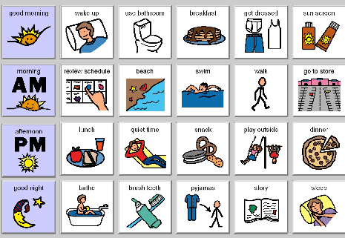
if possible, set it out visually so it is clear,
at a glance, what the day will look like.
One of your daily activities could be creating
this together.
Agree on a set number of key tasks per
day. Remember no one is expecting the
children to be working for the whole day!

- Reduce demands – keep it simple
Try to think of it as practice – keeping their
reading, writing and math’s skills ticking over
rather than trying to teach new information
or move them on too quickly. Many pupils
with ASD are demand avoidant and increasing
demand can lead to anxiety and stress rising
and possible meltdown which will be counter
productive.

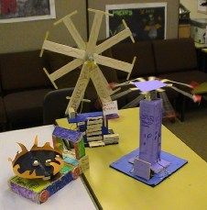
- Not all learning involves writing it down!
Many of our children with Autism are known
for their creativity and skills in designing and
making! Put these skills to good use and have
a project around a theme that can be worked
on over the course of a few days or week.
For example design and build a new fairground
Ride, space craft etc using things you have at home.
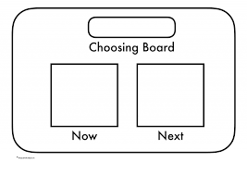
- Now Next Board
We the language Now Next to motivate our
pupils. It gives them incentive to complete the
set/required task (the Now) knowing that a
reward or treat is coming Next!
“Now we are going to do 15 minutes of maths
but next you can choose”
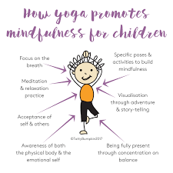
- Focus on Well-Being
Many pupils will miss the routine of school
and will be finding this unusual time very
frightening!
Include some activities during the day that
will support their emotional health and
well-being such as Yoga, relaxation, crafts
mindfulness activities. Sensory diet is also
essential!

- Lego
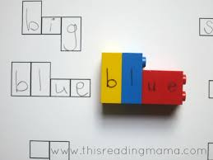
Lego is always a firm favourite but it can
be used in so many ways to promote learning
as well as for good old relaxation and fun!
Lego can be used to visually support spelling
and maths among other things. There are lots
of ideas on line just google Lego Spelling for e.g.
but don’t forget to just let them build, build,
build as this will promote relaxation and mental
well-being.

- Build a den!
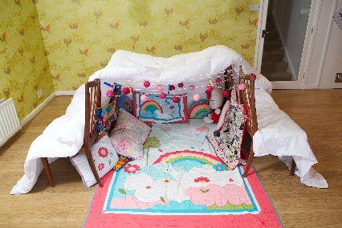
Many pupils with ASD love nothing better than to
hide away in a quiet, safe place. Den building can
be great activity which incorporates design and
making skills, problem solving, collaboration but
ultimately it will give them a perfect hiding place
to chill, unwind and relax the mind. It’s amazing
what you can do with some sheets, towels and
other household objects!

REMEMBER WE ARE NOT EXPECTING YOU TO REPLACE YOUR CHILD’S TEACHER
- Try not to panic about trying to teach your child new skills and knowledge – focus on practice and consolidation
- If things are causing stress, anxiety and meltdowns try different activities and tactics or just take some time out
- 1:1 learning can be intense – no one is expecting your children to do a full school day! Give yourself and your children a break!
- Don’t forget the practical subjects such as PE, Art, Design etc all still count as home learning, it isn’t all about Maths, Writing and Reading.
Some useful links and websites and search ideas:
Google searches:
(these should lead you to a range of websites and resources, not all of which have been tested or checked by us)
- Cosmic Kids – yoga and mindfulness videos on You Tube
- Lego maths
- Lego spelling
- Mindfulness for kids
- Pinterest has many ideas for den building, sensory play, crafts etc
- Sensory activities for children
https://www.kids-konnect.com/blog/7-fun-sensory-activities-for-kids-with-autism
https://positivepsychology.com/mindfulness-for-children-kids-activities/
https://www.autism.org.uk/about/family-life/parents-carers.aspx
https://www.learning4kids.net/list-of-sensory-play-ideas/
http://www.playideas.com/25-awesome-lego-activities-for-kids/
https://www.youtube.com/user/CosmicKidsYoga

