St. Austin’s R.C. Primary School
Heath Street. Thatto Heath. St Helens. WA9 5NJ
Tel: 01744 678000 Fax: 01744 678005
e-mail: staustinrc@sthelens.org.uk
website: http://webfronter.com/sthelens/staustinsprimary
Headteacher: Mrs P. Wade BA; PGCE; NPQH
Growing in Faith Together

Music Policy

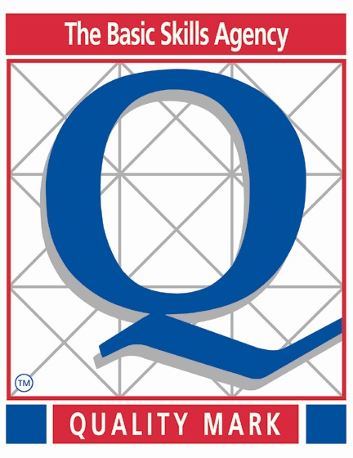








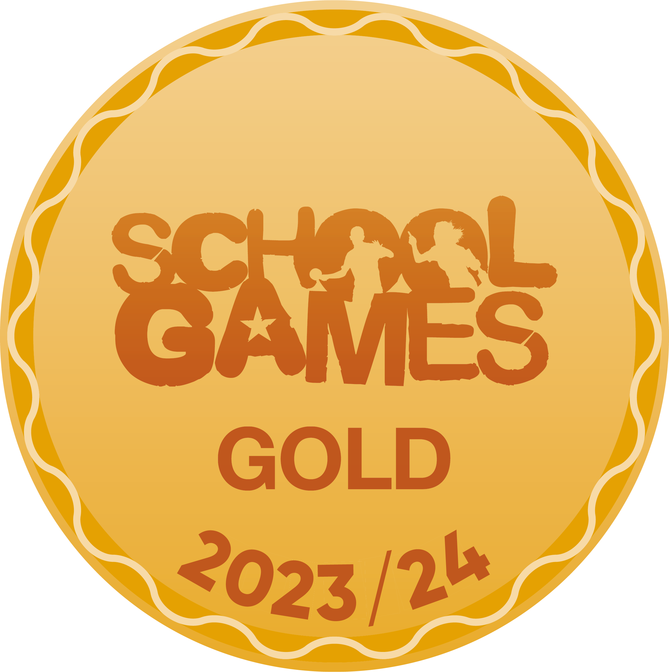
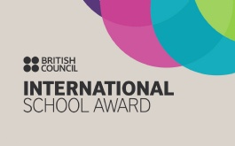
INTRODUCTION

Music is a powerful means of communication and is one of the highest forms of creativity. It brings children together and creates opportunities to work with one another using a universal language. It is an art that can be practiced, appreciated and enjoyed at many levels. Music develops children’s ability to take part in practical activities, both individually and in groups, that encourages and cultivates an enjoyment of different genres of music.
Additionally, music reflects the culture and society we live in and so the teaching and learning of music enables children to better understand the world they live in. It is a creative and fun activity but can also be a highly challenging subject.
It is our aim that all children at St. Austin’s RC Primary School to experience a high-quality, inspiring music education which instils a life-long enjoyment and appreciation for music.

AIMS The aims of music teaching are to enable children to:
• Know and understand how sounds are made and then organised into musical structures;
• Know how music is made through a variety of instruments
• Know how music is composed and written down
• Know how music is influenced by the time, place and purpose for which it was written
• Develop the interrelated skills of performing, composing and appreciating music.

At St. Austin’s RC Primary School, we also aim to:
• Develop the understanding that music can be a social or personal activity.
• Provide experiences and resources which promote knowledge, skills and understanding in music in relation to both their own and the musical traditions of others and of different ages.
• Promote an enjoyable musical curriculum for all children in the school with relevant differentiated experiences.
• Develop children’s ability to observe and respond to the world around them through the use of a wide variety of instruments and musical recordings.
• Through the encouragement of listening to instruments or music for a variety of different reasons, develop children’s listening skills.
• Develop children’s discussion and negotiating skills through working with other children on a given task.
• Celebrate the value of children’s work through recording and performance of their work.
• Recognise ways in which ICT skills may be incorporated into and developed by the Music Curriculum and used to enhance the children’s musical experiences.

PLANNING & ORGANISATION

We provide opportunities for all children to create, play, perform and enjoy music, to develop the skills to appreciate a wide variety of musical genres and to begin to form opinions and critique the quality of music.
A progression of lessons will be planned over a five or six week blocked unit of work that is taught over a half term. The Music units of work will be taught during specific terms where strong and purposeful musical links can be made.
Music teaching and learning is supplemented by schemes of work from ‘Charanga’, an online subscription service. This in-turn informs the medium-term planning as to what is taught within Music teaching units. The short-term plan lists specific learning objectives that are to be covered to support both children and adults in assessing their work and detailed plans are accessed through a log in portal on Charanga.

TEACHING & LEARNING

At St. Austin’s RC Primary School, we make music an enjoyable learning experience. We encourage children to participate in a variety of musical experiences through which we aim to build up the confidence of all children.

We explore music through the inter-related dimensions of music: performing, listening, composing and the history of music. Teaching focuses on developing the children’s ability to sing in tune and with other people. Through singing songs, children learn about the structure and organisation of music. We teach children to listen and to appreciate different forms of music.
As children get older, we expect them to maintain their concentration for longer and to listen to more extended pieces of music. Children develop descriptive skills in music lessons when learning about how music can represent feelings and emotions. We teach them the disciplined skills of recognising pulse and pitch. We also teach children how to work with others to make music and how individuals combine together to make sounds.

Pupils are taught musical notation and how to compose music. Within each music session there will be the following elements: a) A clear Learning Objective which is used by both the teacher and the children to assess the lesson’s work; b) A recap or introduction starter which addresses prior learning or a game. It could also include attention grabbing starters that introduce the children to the theme of the music unit. c) The children then are exposed to new learning or learning in their sequence and how it fits within our theme of work. d) The children are then prompted with various assessment questions and questions to get them thinking a little deeper about the skills they have learnt. Over the course of a unit, the lessons taught will include performance, composition, specific listening tasks, and giving and listening to appraisal and constructive criticism. At least part of each music session involves whole class activities with the opportunity for group work.

We recognise that there are children of widely different musical abilities in all classes, so we provide suitable learning opportunities for all children by matching the challenge of the task to the ability of the child. We achieve this in a variety of ways by:
• Setting open-ended tasks which could have a variety of responses
• Setting tasks of increasing difficulty (not all children complete all tasks)
• Grouping children by ability in the room and setting different tasks to each ability group
• Providing resources depending on the ability of the child
• Using classroom assistants to support the work of individuals or groups of children Key skills are taught through bi-weekly or weekly sessions and through the exploration of new music from all around the world.

FOUNDATION STAGE

We teach music in Foundation Stage as an integral part of the topic work covered during the year and as part of the specific area, Expressive Arts and Design, identified in the Foundation Stage Framework (2024). We relate the musical aspects of the children’s work to the objectives set out in the Early Learning Goals (ELGs). Music contributes to a child’s personal and social development. ‘Counting Songs’ foster a child’s mathematical ability and songs from different cultures increase a child’s knowledge and understanding of the world.

RESOURCES

We have a range of percussion instruments. There is a central store of: • large percussion instruments • selections of instruments from other cultures • xylophones & glockenspiels • Music scheme books • Songbooks and Christmas Production packs • CDs • music stands • recorders • drums.

At St. Austins RC Primary, all staff have a log in for Charanga, this supplies staff with plentiful resources, progression tables and useful webinars to support music development across the school. It is the collective responsibility of all teaching staff to report to the subject coordinator any damaged resources or resource needs to facilitate high quality teaching and learning in music.

ENHANCEMENT

In addition to planned curriculum time for music, children also have additional musical experiences, sometimes the whole school together, sometimes individually, which occur during the school year and contribute to the overall planning and time allocation for music. We endeavour to ensure that children have the opportunity to learn instruments, including violin in extra-curricular sessions throughout the academic year. During the course of the year, pupils in Key Stage 2 also have the opportunity to perform with our school choir. Opportunities are used for musical experiences through a range of activities in other subjects to enable children to apply and use Music in real life and academic contexts e.g. History, PE.

Visitors are also used to enhance the music curriculum where appropriate e.g. St. Helen’s Music. Music is incorporated into a variety of activities and events within school, such as weekly assemblies, singing assemblies, classroom routines and special celebrations. Whole school singing lessons take place during assembly. Children are also offered private violin lessons should they wish to pursue this instrument further.

ASSESSMENT, RECORD KEEPING AND REPORTING

Children’s standards and achievements in Music are assessed in line with the School’s Assessment Policy. On-going Assessment for Learning (AfL) practices within class and group sessions, including the sharing of and reference being made to the Learning Objective and self and peer assessments of understanding, outcomes and progress. Children who are showing a greater depth understanding are also pushed further and signposted to external musical programmes, such as additional musical tuition.
Assessments are used diagnostically by teachers to evaluate learning and inform teaching. Teachers will evaluate individual and groups of children’s standards and achievements to inform future provision and school development. At the end of the year, the teacher makes a summary judgement about the musical skills and development of each pupil in relation to the National Curriculum or Foundation Stage Framework which is recorded in the end of-year report.
Pupils in the Foundation Stage each have a Foundation Stage Profile where teachers record their progress in the Expressive Arts specific area.

INCLUSION

Inclusion is important at St Austin’s RC Primary School; staff will differentiate in order to meet these diverse needs in order to ensure the active participation and progress of all children in their learning. Successful inclusive provision at St. Austin’s is seen as the responsibility of the whole school community, permeating all aspects of school life and applicable to all our pupils. Each lesson is scaffolded to support all levels of learners to ensure everyone is able to access music.
Inclusive practice in Music should enable all children to achieve their best possible standard; whatever their ability, and irrespective of gender, ethnic, social or cultural background, home language or any other aspect that could affect their participation in, or progress in their learning.

THE ROLE OF THE SUBJECT LEADER

The role of the Subject Leader is to provide professional leadership and management for a subject in order to secure high quality teaching, effective use of resources and high standards of learning and achievement for all pupils. They will achieve this by affecting the following key areas: a) Strategic direction and development. b) Learning and teaching. c) Leading and managing staff. d) Efficient and effective deployment of staff and resources. The Subject Leader has regular discussions with staff about learning and teaching in Music and provides an annual summary report (Action Plan) about their work as Subject Leader and an evaluation of the strengths and areas for development for the subject. During the academic year the Subject Leader has specific allocated time for subject self-evaluation activities.

MONITORING AND REVIEW

The Head teacher and Music Subject Leader will monitor the effectiveness of this policy on a regular basis. The Head teacher and Music Subject Leader will report to the governing body on the effectiveness of the policy annually and, if necessary, makes recommendations for further improvements.

Last Date of Review- N. Johns 23.09.24
Next date of Review- September 2025

